|  |  |
| --- | --- |
|  | **Example:**  **Trigonometric Identities** |

**Objective:** To explore some relations of trigonometric ratios

**Key Stage:** 3

**Learning Unit:** Trigonometry

**Materials Required:** *Microsoft**Excel* and file Trigo_Iden.xls

**Prerequisite Knowledge:** Definitions of the trigonometric ratios for acute angles

**Description of the Activities:**

*Activity I: Relations between trigonometric ratios,* , ,  *and* 

1. The teacher briefly reviews the definitions of sine, cosine and tangent ratios of an acute angle at the beginning of the lesson.
2. 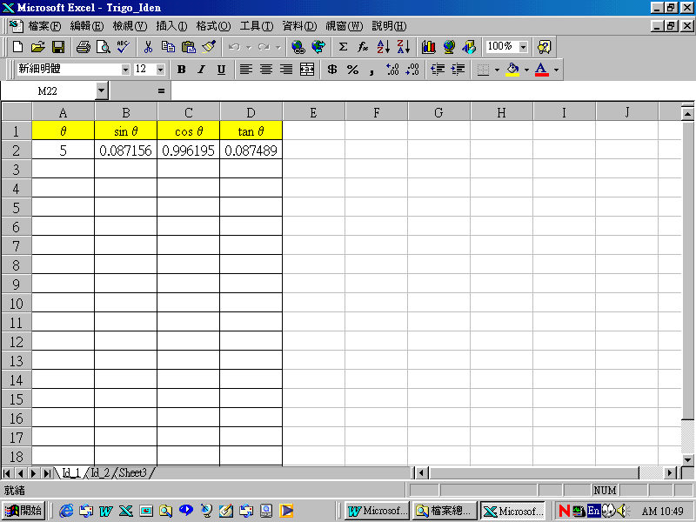The teacher divides students into groups of two. The teacher distributes Worksheet 1 and the *Excel* file Trigo_Iden.xls to each student. Each group needs to use the worksheet "Id_1" in the *Excel* file to find a relation between sinθ, cosθ and tanθ (see figure below).   
   Students are expected to fill in other values of θ in step 5 of Worksheet 1. The computer can be used to generate their corresponding values of trigonometric ratios. From these, students are expected to discover the trigonometric relations , ,  and .
3. If students cannot discover the above relations, the teacher may suggest students to consider sin θ + cos θ, sin θ − cos θ, sin θ × cos θ, sin θ ÷ cos θ, sin2θ and cos2θ in the columns E to J respectively.
4. Students may also find that the relations still hold for other values of θ such as 1°, 37°, 32.5°, 68.7°, etc.
5. The teacher asks students to discuss with their partners the proofs of these relations. Worksheet 2 is distributed to them. They are expected to write down their proofs.
6. The teacher summarises the result and gives the proof to students if necessary.

*Activity II: Relation between*  *and*  *(Homework Assignment)*

1. As students have learned that there may be some connection between 90° − θ and θ, it is natural for them to consider  and  in order to explore a relation between these two quantities.
2. 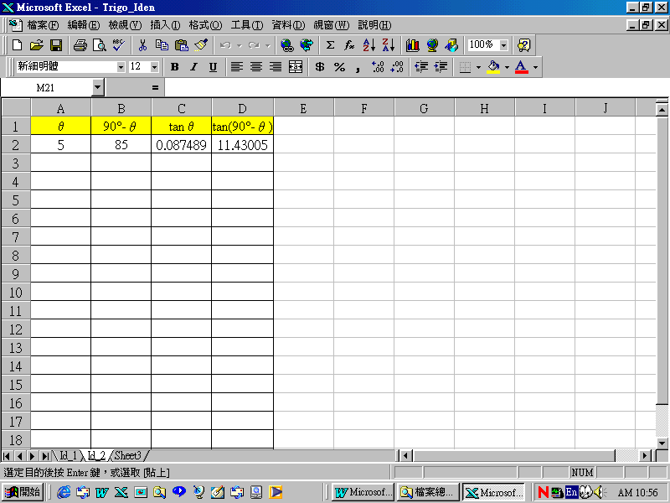The teacher distributes the *Excel* file Trigo_Iden.xls to students (see figure below). Students need to select the worksheet “Id_2” to explore a relation between  and  as a homework assignment. They are also required to suggest a proof to their conjecture.
3. The teacher gives the answers to students after students hand in their assignments.

**Worksheet 1: Relation among sin θ, cos θ and tan θ**

1. Open the *Excel* file Trigo_Iden.xls and select the worksheet “Id_1”.
2. Input the values between 10 to 85 in cells A3 to A18.
3. Calculate the corresponding values of ,  and  by copying the formula of B2 to cells B3 to B18, etc.
4. Can you find a relation / relations among the trigonometric ratios?

Write down your conjecture(s) below.

If not, calculate the corresponding values of sin θ + cos θ, sin θ − cos θ,   
sin θ × cos θ, sin θ ÷cos θ, sin2θ and cos2θ in columns E to J.

_________________________________________________________________

_________________________________________________________________

_________________________________________________________________

1. Enter different values of θ such that 1°, 37°, 32.5°, 68.7°, etc. Repeat the calculations stated in step 3. Does your conjecture(s) in step 4 still hold?

_________________________________________________________________

_________________________________________________________________

_________________________________________________________________

_________________________________________________________________

_________________________________________________________________

1. Make reference to the *Excel* file and fill in the table below.

|  |  |  |
| --- | --- | --- |
| sin 5° | = | cos ( ) |
| sin 10° | = | cos ( ) |
| sin 15° | **=** | cos ( ) |
| sin 20° | = | cos ( ) |
| sin 25° | = | cos ( ) |
| sin 30° | = | cos ( ) |
| sin 35° | = | cos ( ) |
| sin 40° | = | cos ( ) |
| sin 45° | = | cos ( ) |
| sin 50° | = | cos ( ) |
| sin 55° | = | cos ( ) |
| sin 60° | = | cos ( ) |
| sin 65° | = | cos ( ) |
| sin 70° | = | cos ( ) |
| sin 75° | = | cos ( ) |
| sin 80° | = | cos ( ) |
| sin 85° | = | cos ( ) |

1. Can you find a relation between sin θ and cos θ?

[Hint: sin θ = cos ( ? ) and cos θ = sin ( ? )]

Write down your conjecture(s) below.

_________________________________________________________________

1. Does your conjecture in step 7 above still hold for other values of θ ?

_________________________________________________________________

**Worksheet 2: Proofs of the Trigonometric Relations**

1. To prove that .

(a) Express the trigonometric ratios in terms of *a*, *b* and *c*.

(*)

|  |  |  |
| --- | --- | --- |
| Fig.1 | (i) sin θ = |  |
|  |
|  |
|  |
| (ii) cos θ = |  |
|  |
|  |
|  |
| (iii) tan θ = |  |
|  |
|  |
|  |

(b) (i) Using the results of (a) (i) and (a) (ii), find  in terms of *a*, *b* and *c*.

________________________________________________________

________________________________________________________

________________________________________________________

1. Comparing your result in b(i) with that in (a) (iii), what do you notice? Write down your conclusion.

________________________________________________________

________________________________________________________

________________________________________________________

________________________________________________________

1. Use Fig.2 to prove that .

Fig.2

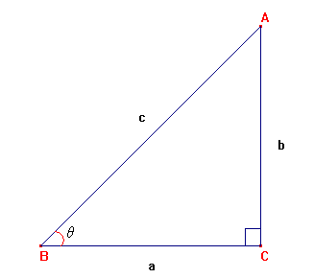

Proof:

1. Use Fig.3 to prove that  and .

Fig.3



Proof:

**Notes for Teachers:**

1. This exemplar aims at developing the trigonometric relations , , ,  and .
2. The teacher should remind students that the units for the angles are omitted in the *Excel* file for convenience. As a result, we input 10 instead of 10°, etc. Besides, in *Excel*, the calculations of built-in functions are in the radian measure. Some convention must be made to change the input angle from the degree measure to the radian measure in order to use the built-in functions. This is the reason why we enter the formula “=sin(A2*PI( )/180)” into cell B2 to calculate the value of sin θ in the worksheet "Id_1" of the *Excel* file Trigo_Iden.xls.
3. The meanings of sine, cosine and tangent for the special angles 0° and 90° are not introduced here. The teacher may remind students that the trigonometric relations in this exemplar still hold for these special angles.
4. For the less able students, the teacher may suggest students to add a column as a hint to the investigation in the homework assignment in Activity II.